1. **ABSORB III DEV CRF VERSION**

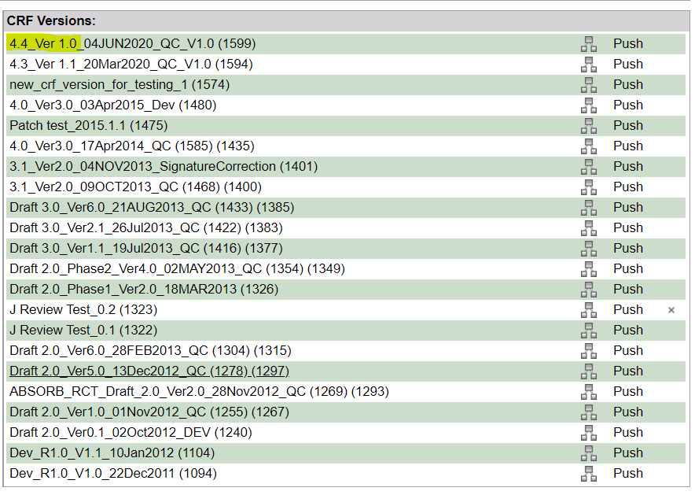

1. **PROD CRF VERSION FOR ABSORB III**

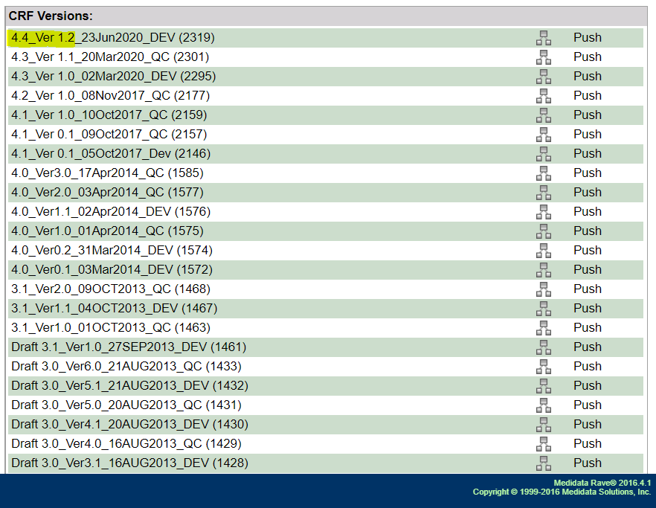

1. **ABSORB IV DEV CRF VERSION**

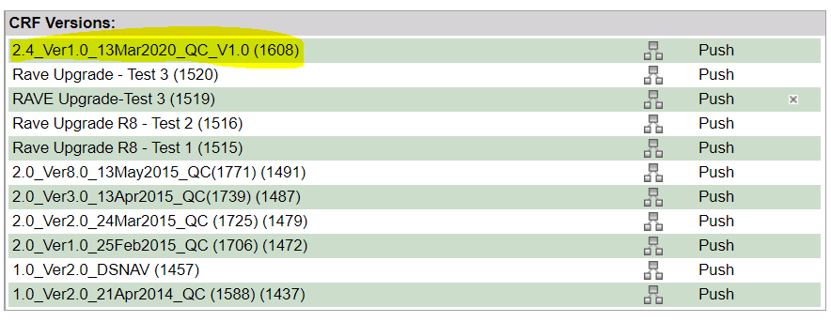

1. **ABSORB IV PROD CRF VERSION**

